When creating a chart, if you want the stuff on Y axis, put it on the rows, X axis is column

Connect to SQL using Live VS Extract

* Live is real-time update, with any changes in the data source reflected in Tableau
* Extract, you can set up a refresh schedule

50 video <https://youtu.be/1BLywLrQUcE>

Its video 1-5 is good, 6-12 is different chart type, Skip them

DIY# 1 Load data, click sheet 1

DIY# 2-of-50 Creating Sets and Calculations and Group- <https://youtu.be/KNx_rXXLQRo>

Set is like a filter. Calculated field is to group data based on the Set, the filter

Create set on Dimension using Measure value allow you to set condition filter, choose some date field, greater than, less than, Top 10,

* Right click the field you want, create Set, if u need two **quantitative** sets, one set is customer < 5k, another set is customer > 10k, create them separately, drag them to the **filter** box
* calculated field: Group and color customers based on their sale amount, need create, right click the sales amount, click calculated field, enter the following code, which combine the Two Sets you just created into calculation, then drag to the color box

IF [customer < 5k] then "small"

elseif [customer > 10k]then "large"

ELSE "medium"

END

------if I just enter below code in calculated field and drag to color box, **Fail**

IF [Sales Amt] >= 10000 THEN ("large")

elseif [Sales Amt] < 10000 AND [Sales Amt] > 5000 THEN ("medium")

ELSE ("small")

END

**Highlight the Top 3**

Rank(Sum([Sales]))<=3

How set order in each category? Table Calculation—Rank---Pane Down

* Create Group is to create a sub category, can be drag to rows and columns, to divide data, not exclude data
* if u want to group some Items together = split them into different big category, <https://youtu.be/fbYOKyx8xH0>

do it in here

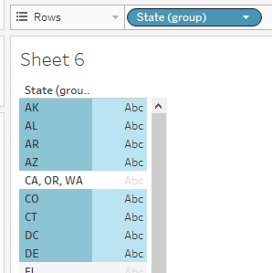

DIY# 3-of-50 Top N Analysis & Sorting <https://youtu.be/PkgrcY-Vzoo>

Create SORT Left click the tab on Rows/ columns

Create TOP 10 Right click the field you want, create Set,

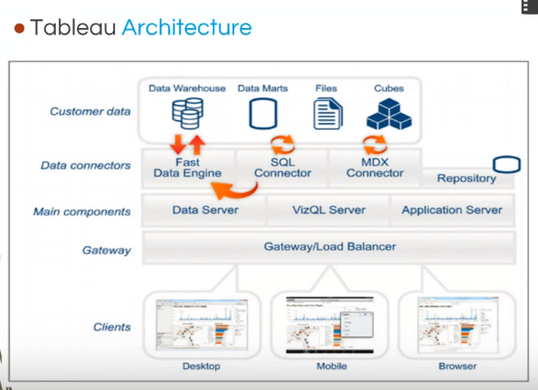

1) Creating Parameters are a set list of values, like creating an option for user to choose, by country or by department

<URL:https://youtu.be/aclMW-Gjwf0>

1.Right Click Customer Country, and create a parameter "Pick Parameter"

2. Click on "Clear All" button to clear out all values.

3 Add two values Country and Department.

4 Create a new calculated field " Show Dimension ", and then use the if statement as shown.

if([Pick Parameter] = 'Country') then ([Customer Country])

else([Department])

end

7 Right click the parameter and Show parameter control.

8 Add the calculated field "Show Dimension", and a measure Sales Amt.

9 Change the parameter, in the Show param control.

=============put Location Sale $ Person 3 things together in Chart

1. Right Click on the Employee Name from the left side, Create Set for Employees, having Sales_Amt < 2000.

Sales_Amt > 4000

2. create a calculated field with the name "Employee Sales Band".

**Use the following formula:**

If [SA less than 2k] then "Band less than 2k"

elseif [SA greater than 4k] then "Band greater than 4k"

else "Band 2k to 4k"

end

3.Add the Employee Location from the dimensions to the column

4.Add Sales Amount in the row

5.Drag calculated field "Employee Sales Band" to Color box

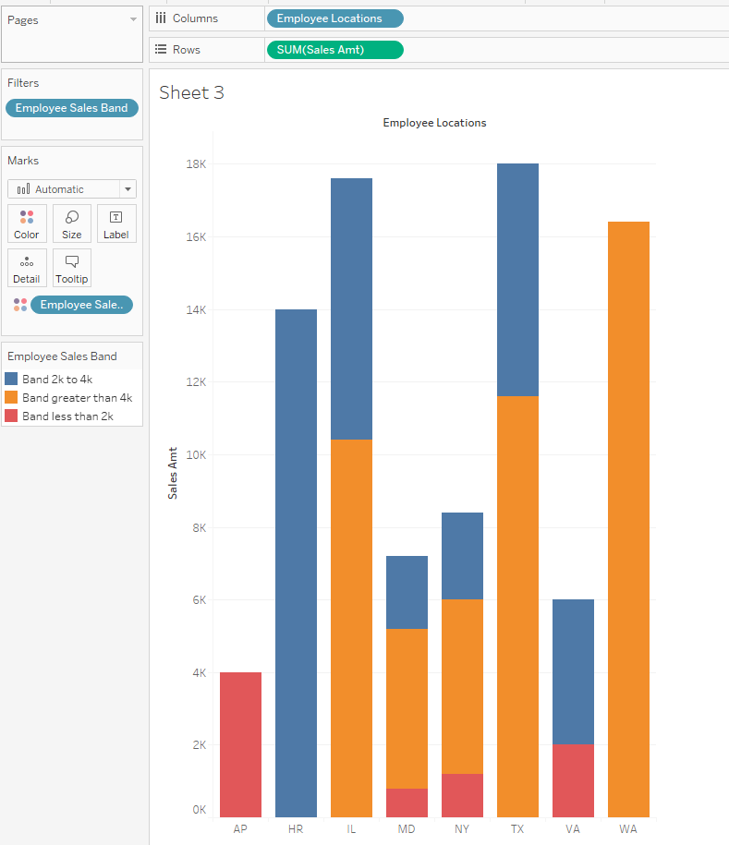

Video 13, Dual axis, drop down the sales cost, choose dual

14-of-50 Window Functions -: click Analysis tab, create a calculated field, Calc_Window_Func

Type the following function - WINDOW_SUM (SUM( [Sales Cost]), -1, 0)

Drag sale cost to the chart, double click the Calc_Window_Func

Drag Calc_Window_Func to the last column

Creating Stories - DIY -21 <https://youtu.be/CfQMjXaCOuM>

At the bottom, click Add new story, drop dashboard to story, and provide a narration [nə'reʃən] of the visualizations. And if want add more slice, click **New Blank Point**

Combine multiple worksheets into one dashboard, use one of the worksheet as filter

Type formula to rows bar to get AVG

========================================================================================

Data Blending: table from different data source <https://youtu.be/dZKgIA6Pe_c>

* Data tab---Edit relationship, add relationship between two data sources, or rename one data source’s name, Tableau will auto create relationship. When u drag the first data source to rows, it become primary
* How to deal with a star icon? Swapping the secondary data source to become the primary data source

Complex joins multiple tables together <https://youtu.be/yqCiVtwc0XM> every time join new table, look back the original amount of data, to see if it mess up. If it does, then we use Blending

Real example to analyze What’s the correlation between sales and coupon code? <https://youtu.be/bQvwI5JY6dY> 官方视频

Facebook Insights with Visual Analysis https://youtu.be/T5cNZja_SE8

Analyzing Twitter Data <https://youtu.be/uWIhdlnkEOM>

A/B Testing with Tableau at Kobo <https://youtu.be/zElPjduWu4s>

Think Data Thursday: Behind the Scenes with Tableau's Social Media Data <https://youtu.be/Gx487JVkNuQ>

=================real world example, hand on Social Media and Web Data

Think Data Thursday: Make Social Media and Web Data Work For You <https://youtu.be/KxS_kfNbtxw>

How to get data:

* export directly from FB, twitter
* get live data from Data sift, Gnip
* twitter streaming API or tableau Web Data Connector

**Project 1 collect and analyze data about company’s facebook page**

* When is the best time to post our content to make sure that the highest number of people are viewing that content?
* What type of content do people find the most engaging?
* How active are our social media marketing team on FB?

Download data from facebook page every time, tableau 9.1 has web data connector

1. Take a look the number of posts over time, I can clearly see the first thing that was posted was back in 2005 and there’s been a very steady increase year over year.
2. I want to get more detail on that. Drill into the TIME and look at it on a monthly basis.
3. Let’s do it by year and by month.
4. Compare the year over year number of posts for any particular month, so I’s interested in understanding whether our marketing team posted more than in Oct 2015 compared with Oct 2014. DRAG Sum of posted into Color ICON, tell tableau that this is going to be a table calculation, Compare year over year growth, anywhere we’ve had a dip in the Y-O-Y growth, I make sure it shows up in red. So now, we’re getting a bit more insight into the data where our marketing team are posting. We can see there’s a very strong upwards trend year over year. There were some months which are showing up red now, where compare the # of posts in that particular month of that year with previous year. We’re posting a bit less.

**What type of content do people find the most engaging?**

1. look at the # of times a post has been liked and the # of time the post has been shared. First of all, I’m going to look at a # of likes, so I want to know the average # of likes for every play. So we can see across the data we’re getting on average 10 likes per post.
2. I want to look at this at a post level, DRAG post ID to DETAIL BOX to see which specific posts have been like the most.
3. Let’s look at this over time as well, on a monthly basis (the best time interval)
4. I’m also interested in understanding what type of content people like the most, so I’m going to DRAG the type of content on to color and now I can start to see which of those posts were links that are showing up in orange. I can start to get a really good understanding now of what type of content people are engaging with the most and liking the most on Facebook.
5. The other thing I might want to do is bring the MESSAGE onto the TOOLTIP, so now if I hover over any of these DATA POINTS, I can get even more understanding as what that particular post was about and I can see for example that the post that has been like the most on Facebook was back in February 2016, and it was a post about our position in the world.

**When we’re posting the most? Heatmap**

1. DRAG # posts in COLOR, I’m going to break this down by the day of the week, by weekday and by hour of the day
2. Change the color, so we can really emphasize those hours in the week where we’re posting the most amount of content, so I have this heatmap

Finally, I can bring all of that analysis together on a dashboard and make it interactive so if I’m interested in understanding what’s being posted on Monday. I can click on Monday and see exactly what the patterns and trends look like.

--------------**twitter data** to capture huge number of tweets that are out there that may be relevant to our organization

* What tweets are people engaging with the most?
* Where do people live that Twee about us?

-------------Google analytics Case

* How many people visit my website?
* When do they visit and where do they come from?
* What affect does new content have on page views and average time spent?

**Sessions:** represent the number of individual sessions initiated by all the users to your site.

**Pageviews**: If a user navigates to a different page and then returns to the original page, a second pageview is recorded as well

1. we look at the average amount of time that people spend on our website, then take a look at it on the weekly basis
2. Compare the specific dates that I posted on my website, I’m going to overlay the chart. Right click it, make it dual axis chart, synchronize those axes, also bring across information summary of the website, I can now see, for example, that on the May 1st, when we posted a news about XXX, that seems to cause a huge increase in the average of time that people spend on our website. But in the subsequent weeks after posting that, it did seem to drop off quite a bit again, until July of last year, when we’ve posted a new article, seems to have the biggest impact on the amount of time that people have been spending on our web.
3. I could do something very similar looking at the number of the total number of views, and the overall web traffic. On Sep, there’s something else which cause the spike.
4. I can bring that analysis together into a dashboard and share the insight with my colleagues.

白人讲：For example, at a precious position, I was one who contributed to the rapid increase in website traffic at a 10% rate by using successful marketing and advertising strategies, so I had success and I look for doing the same with your company.

-------------------------weather case

They discovered that a two degree increase in temperature caused a huge spike in their sales figure.

**Continuous VS Discrete**

If a field has values that are numbers that can be added, Tableau assigns that field to the Measures area of the Data pane when you first connect to a data source. Tableau is assuming that the values are **continuous**. variables that are continuous values

Anything other than numbers—Tableau assigns that field to the Dimensions area of the Data pane when you first connect to a data source. Tableau treats the values as **discrete**. variables that are categorical and unordered

**How to automate tableau?**

Create a schedule

===================================

Tableau interview question <https://www.youtube.com/watch?annotation_id=annotation_1608818163&feature=iv&src_vid=1BLywLrQUcE&v=wWXWv1T72q8>